OOP Semester Project

Café Management System

Instructor
Dr. Sumaira Farid
Submitted By:
Daniyal Haider
{241947}
Abdul Moeed Raza Kazmi
{241920}
Sheikh Abdullah Bin Faisal
{241869}

Department of Computer Science
25-5-2025
- Introduction:
The project is Café management using the concepts of Object Oriented Programming. The system includes the functionalities for both customer and manager. You can register as a customer, order, track order, delete account and other functionalities. The manager can change his/her password, check stock and revenue, update stock and prices, add items in menu and other functions.

- Objective:
This Café management system, built with Object-Oriented Programming, enables customers to place and track orders while allowing managers to manage stock, revenue, and menu updates.

- Implementation Details:
- Classes:
User: It is the parent class.
Customer: It is the child class of User.
Manager: It is a second class for the functionalities of a manager.

- Attributes:
User(Parent): Name, address and phone.
Customer(child): Password, email and username.
Manager: Name, password, item name, item price, item quantity and order id.

- Functions:
- User:
- Menu(): This function asks whether you are a customer, manager, register as a customer or exit.

- Customer:
- Login(): This function serves as a login page for customers.
- Register(): This function serves as a registration page for customers.
- changeCredentials(): This helps the customer to change their details.
- RegisterComplaint(): This function is used to give feedbacks.
- deleteAccount(): This function is used to delete customer account.
- generateReceipt(): This function generates the receipt of the order.
- Payment(): This function asks whether the payment is via cash or card.

- Order:
- placeOrder(): This function is used to order food.
- viewOrder(): This function is used to view their order.
- trackOrder(): This function tracks the status of order.

- Manager:
- Admin(): This function allows manager to login.
- ViewStock(): This function allows manager to view stocks.
- AddItems(): This function allows manager to add items into the menu.
- RemoveItems(): This function allows manager to remove items in the menu.
- Revenue(): This function allows manager to view revenue.
- ChangePassword(): This allows manager to change his/her account password.
- ViewFeedback(): This allows manager to view customers’ feedbacks.
- UpdatePrice(): This function allows manager to update the price in the menu.
- ViewCustomerInfo(): This function allows manager to view customers’ information.
- Addstock(): This function allows manager to add stocks in the inventory.

- UML Diagram:

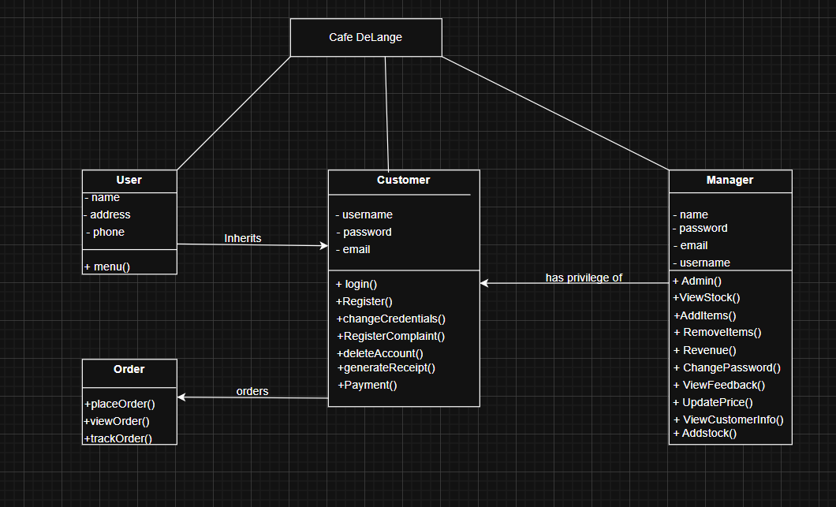

- Necessary Code:

- User.h:
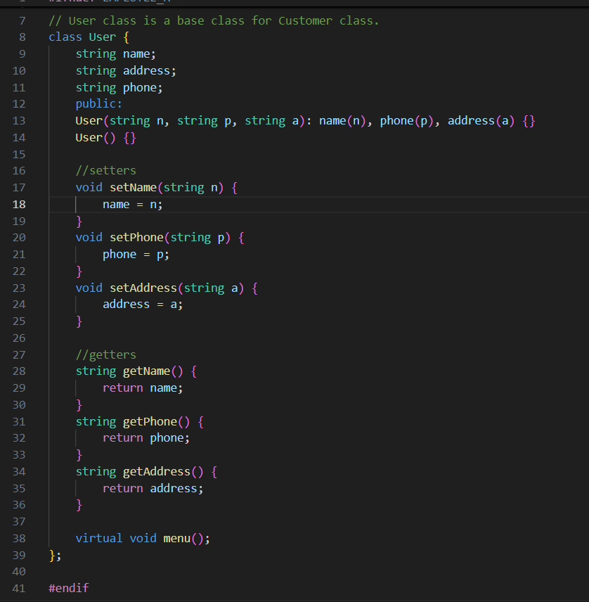

- Customer.h:
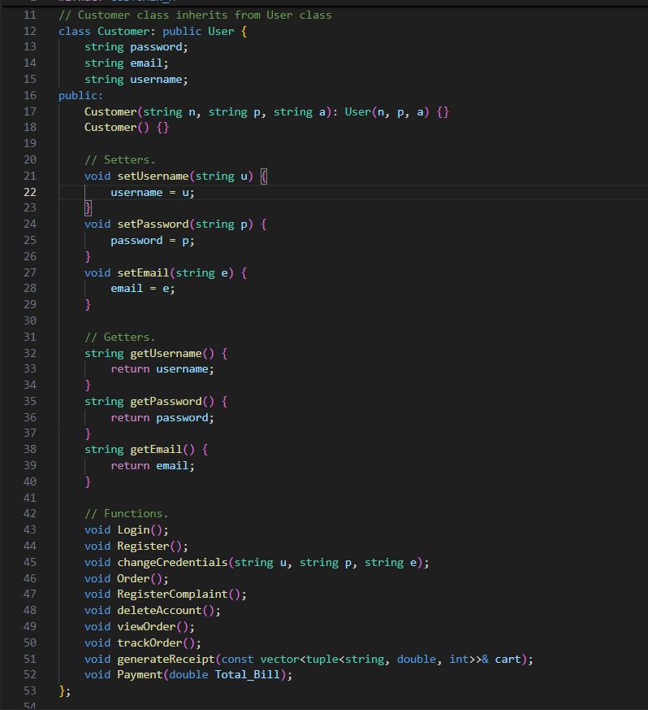
- Manager.h:
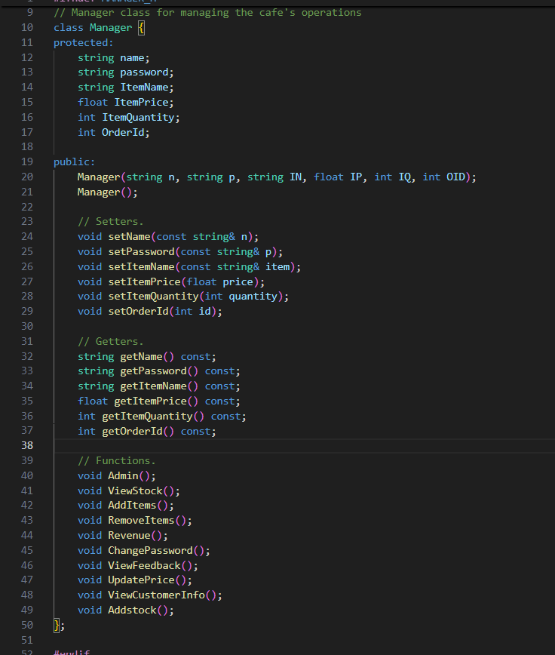

- Order.h:
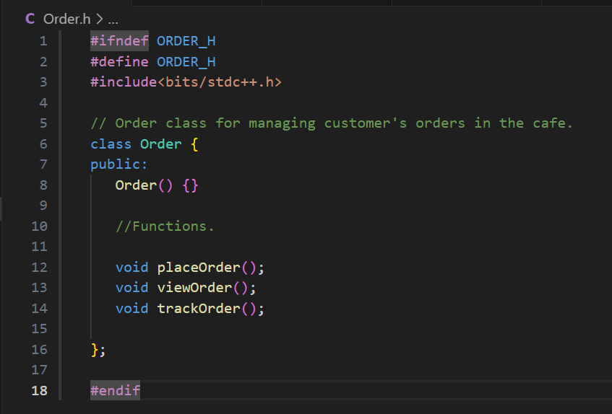

- Output Screenshots:
